**Introduction:-**

Image Denoising is one of the fundamental challenges in the field of image processing and computer vision, where the underlying goal is to estimate the original image by suppressing noise from a noise-contaminated version of the image. In Image Denoising we try to remove the noise from an image by using certain techniques so as to recovers the original image by retaining its quality, which gets corrupted during its acquisition or transmission. Therefore, image denoising plays an important role in a wide range of applications such as image restoration, visual tracking, image registration, image segmentation, and image classification, where obtaining the original image content is crucial for strong performance.  Noisy images are generally produced during medical procedures which require instruments to produce detailed pictures of the inside of your body such as MRI, CT scan, ultrasound, x-ray etc. In medical operation it is important to denoise an image so as to recover the suppressed anatomical details due to the noise. Bio-medical images are normally - corrupted with noise; which degrades the useful detail of medical images which may affect the diagnosis. In Bio-medical images the denoising should be done by balanced edge preservation as edges are an important aspect of the image. Thus, all medical imaging devices need denoising technique to enhance the image quality which will help the doctors and medical experts for proper diagnosis. In traditional denoising techniques, to improve the quality of the image the filter such as Median filter, Gaussian filter and Fspecial filter are directly applied over noisy image. But in our proposed method we first decompose the noisy image using BEMD(Bi dimensional Empirical Mode Decomposition) then we filter out the three images obtained from the decomposed image and add it to make a new and better image which recovers more details of the original image than the traditional method. In traditional method we directly apply the filter to the noisy image but in our proposed method we decompose the image into four parts using BEMD then we apply the filter to the IMF1, IMF2, IMF3 individually and adding these three images with residue image we get a better quality image than the traditional method. In our proposed method we have used BEMD instead of DWT(Discrete Wavelet Transform) because [1]. IDWT(Inverse Discrete Wavelet Transform) is required to reconstruct the image from the decomposed images and [2]. DWT is an image independent technique.

2

**Methodology:-**

The proposed method gives us a brief idea about the image decomposing and denoising of a bio-medical image. In this method we improve the image quality and it also retrieves the lost data due to noise. The proposed algorithm first decomposes the original image (I) into low frequency and high-frequency components using BEMD, where the low frequency and high-frequency components stand for detail and approximation information. In our proposed method we use BEMD where we decompose an image into three parts of IMF’s and one part of residue. The residue contains edge information of the original image. In the traditional method we used to directly apply the filter to the image to improve the quality. In our proposed method we first decompose the image into four parts by using BEMD and we apply filters to three IMF’s individually and the add all the three filtered decomposed images with the residue image and get a new image which has better quality than the image obtained from the traditional method. Firstly BEMD takes the high frequency and low frequency of the original image and divides it by two to get the IMF1 and then it subtract the mean from the original image and then from the rest of the subtracted image then it repeats the process to get IMF2 and IMF3 and the part which is left is the residue image.

**BEMD:-**

BEMD is to decompose bi-dimensional image into intrinsic mode functions (IMFs) and residue like one dimensional EMD. Someone used EMD to image denoising, which viewed the image as one dimensional row signals. The overall process can be broken down into four steps. First, images are decomposed using BEMD arithmetic to extract the [Intrinsic Mode Functions](https://www.sciencedirect.com/topics/engineering/intrinsic-mode-function) (IMFs). Then, these IMFs could be examined using gradual single frequency signals to bring out and highlight the physical meaning of [instantaneous amplitudes](https://www.sciencedirect.com/topics/computer-science/instantaneous-amplitude) and [instantaneous frequencies](https://www.sciencedirect.com/topics/computer-science/instantaneous-frequency).

The detailed process can be described as follows

1. Look for the local extremum and form the envelopments of the original image $f\left(x,y\right)$.
2. Compute the average $m_{1}\left(x,y\right)$ of the top envelopment and bottom envelopment and denote that $l_{1}\left(x,y\right)=f\left(x,y\right)-m_{1}\left(x,y\right)$
3. Replace $f\left(x,y\right)$ with $l_{1}$ (x,y) and execute the above three steps. Then we can get $l_{i}\left(x,y\right)$) until the standard deviation SD is smaller than the threshold predefined. We used $l_{1}$ (x,y) to replace $l_{i}\left(x,y\right)$.If the local mean of $l_{i}\left(x,y\right)$ is zero, we view it as ${imf}_{1 },where$

SD= $\sum_{x=0}^{x}{\sum_{y=0}^{y}{\left(\frac{{{[l}_{i+1}\left(x,y\right)-l_{i}(x,y)]}^{2}}{{l_{i}}^{2}(x,y)}\right)}}$

1. 4) Replace $f\left(x,y\right)$ with $f\left(x,y\right)$- $I_{1}(x,y)$ and execute the above four steps until the extremum number of residue is smaller than two. Then we complete the decomposition.

$f\left(x,y\right)$ = $\sum_{i=1}^{N}{{imf\left(x,y\right)+}_{r_{N}}(x,y)}$

**Noises:-**

Image noise may be defined as any change in the image signal, caused by external disturbance Noise generated by electronic devices varies greatly as it is produced by several different effects. Normally images are disturbed by Salt & Pepper, Gaussian and Speckle noise.

**Salt & Pepper Noise:**

Salt-and-pepper noise is a sparsely occurring white and black pixel sometimes can be seen on images. Median filter or morphological filter methods considered as a common reduction methods of this type noise of noise. The Salt & Pepper noise is generally caused by defect of camera sensor, software failure, or hardware failure in image capturing or transmission. The Probability density function ‘S’ of a Gaussian random variable ‘u’ is given by:

$$S\left(u\right)=S_{p } for u=0\left(Pepper\right)$$

$$S_{s }for u=2^{n}-1\left(Salt\right)$$

$${1-(S}_{p }+S_{s }) for u=k(0<k<2^{n}-1)$$

**Gaussian Noise:**

Gaussian noise is [statistical noise](https://en.wikipedia.org/wiki/Statistical_noise) having a [probability density function](https://en.wikipedia.org/wiki/Probability_density_function) (PDF) equal to that of the [normal distribution](https://en.wikipedia.org/wiki/Normal_distribution), which is also known as the [Gaussian distribution](https://en.wikipedia.org/wiki/Gaussian_distribution). In other words, the values that the noise can take on are Gaussian-distributed.

The probability density function {\displaystyle p}of a Gaussian random variable {\displaystyle z}is given by:

$$h\left(v\right)=\frac{1}{∂√2π}e^{\frac{(μ-μ^{2})}{2δ^{2}}}$$

**Speckle Noise:-**

Speckle noise is the noise that arises due to the effect of environmental conditions on the imaging sensor during image acquisition. Speckle noise is mostly detected in case of medical images, active Radar images and Synthetic Aperture Radar (SAR) images. Various researchers have performed experiments to overcome this kind of noise using different filtering techniques based on soft computing approaches, such as Fuzzy Filter, Genetic Algorithm, Particle Swarm Optimization, and Artificial Bee Colony

$$F\left(u\right)=\frac{u^{α-1}}{(α-1)!a^{α}}e^{\frac{-u}{a}}$$

Where:

u: Grey level

𝑎 α : Variance

**Filter:**

In image processing filters are mainly used to suppress either the high frequencies in the image, smoothing the image, or the low frequencies, enhancing or detecting edges in the image.

**Median filter:**

It is a nonlinear method widely used to remove ‘salt and pepper’ type noise. The median filter works by moving through the image pixel by pixel, replacing each value with the median value of neighbouring pixels within pre-defined window size. The median is calculated by first sorting all the pixel values from the window, and then replacing the pixel being considered with the middle (median) pixel value. Then the window slides, pixel by pixel over the entire image.

**Gaussian filter:**

A Gaussian filter is a linear filter. It's usually used to blur the image or to reduce noise. If you use two of them and subtract, you can use them for "unsharp masking" (edge detection). The Gaussian filter alone will blur edges and reduce contrast. Gaussian filters have the properties of having no overshoot to a step function input while minimizing the rise and fall time. This behaviour is closely connected to the fact that the Gaussian filter has the minimum possible [group delay](https://en.wikipedia.org/wiki/Group_delay). It is considered the ideal [time domain](https://en.wikipedia.org/wiki/Time_domain) filter, just as the [sinc](https://en.wikipedia.org/wiki/Sinc_filter) is the ideal frequency domain filter.

**Fspecial filter:-**

Fspecial filter creates a two-dimensional filter, h, of the specified type. Fspecial returns h as a correlation kernel, which is the appropriate form to use with imfilter is a string having one of these values h = fspecial ('average’, size) returns an averaging filter, h, of size hsize. The argument hsize can be a vector specifying the number of rows and columns in h, or it can be a scalar, in which case h is a square matrix. The default value for hsize is [3 3].

**Experimental Results:-**

**Performance measures evaluation:-**

**MSE:**

The MSE represents the cumulative squared error between the compressed and the original image. The lower the value of MSE, the lower the error and better quality of compressed image. It is calculated as:

$$MSE=\frac{1}{pq}\sum_{a=0}^{p-1}{\sum_{b=0}^{q-1}{[I\left(a,b\right)-K(a,b)]^{2}}}$$

Where *p q*: Dimension of the image.

I (a, b): Intensity of pixels (a, b) in original image.

K (a, b): Intensity of pixels (a, b) in de-noising image.

**PSNR:-**

Peak signal-to-noise ratio, is the ratio between the maximum possible power of a [signal](https://en.wikipedia.org/wiki/Signal_(information_theory)) and the power of corrupting [noise](https://en.wikipedia.org/wiki/Noise) that affects the fidelity of its representation. PSNR is most commonly used to measure the quality of reconstruction of lossy compression [codecs](https://en.wikipedia.org/wiki/Codec" \o "Codec) (for [image compression](https://en.wikipedia.org/wiki/Image_compression)). The signal in this case is the original data, and the noise is the error introduced by compression. When comparing compression codecs, PSNR is an approximation to human perception of reconstruction quality. Higher the value of PSNR, better the quality of compressed image. PSNR is calculated as:

$${PSNR}_{db}=10\log_{10}(\frac{{MAX}^{2}}{MSE})$$

= $20\log_{10}(MAX)- 10\log_{10}(MSE)$

Where,

MAX: Maximum possible pixel value of the image.

MSE: Mean Square Error

**SSIM:-**

Structural similarity index (SSIM) is a method for predicting the perceived quality of digital television and cinematic pictures, as well as other kinds of digital images and videos. It is used for measuring the similarity between two images. It’s a [full reference metric](https://en.wikipedia.org/wiki/Video_quality#Classification_of_objective_video_quality_metrics) and perception based model that considers image degradation as perceived change in structural information, while also incorporating important perceptual phenomena, including both luminance masking and contrast masking terms.

$SSIM(a,b)=[q(a,b)]^{α}[w(a,b)]^{α} [e (a,b){] }^{γ}$

Where,

$$q(a,b)=\frac{2μ_{a}μ_{b}+c1}{μ_{a^{2}+μ_{b^{2}}+C1}}$$

$$W(a,b)=\frac{2δ_{a}δ_{b}+c2}{δ_{a^{2}}+δ_{b^{2}}+c2}$$

$$e(a,b)=\frac{δ_{ab}+c3}{δ_{a}δ_{b}+c3}$$

Where,

$μ_{a}=Local mean for iamge a$

$μ_{b}=local mean for image b$

$δ_{a}=standrad deviation for image a$

$δ_{ab }$ = cross co-variance for image a,b

${ δ}_{b}= standrad deviation for image b$

If α = β = γ = 1 and C3 = C2/2 then the above index is simplifying to:

SSIM = $\frac{(2μ_{a}μ_{b}+c1)(2δ_{a}δ_{b}+c2)}{{{(μ}_{a}}^{2}+{μ_{b}}^{2}+c1)({δ_{a}}^{2}+{δ_{b}}^{2}+c2)}$

**Block Diagram:-**

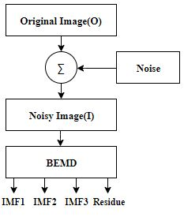

**Noisy Image decomposition using BEMD**

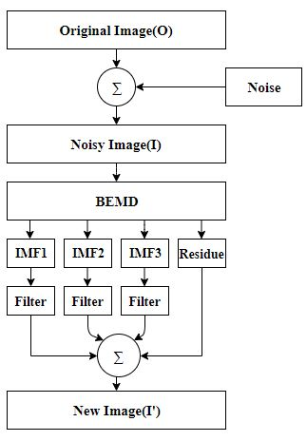

**Proposed Method**

**Experimental result graphs:-**

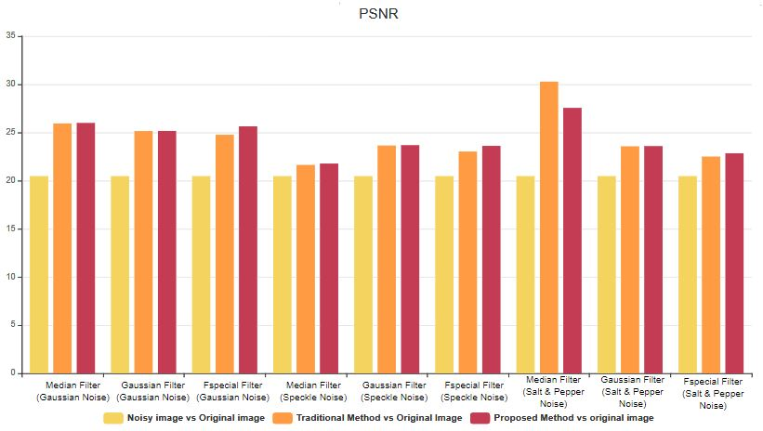

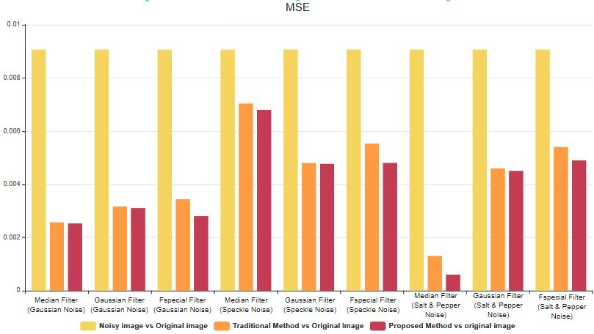

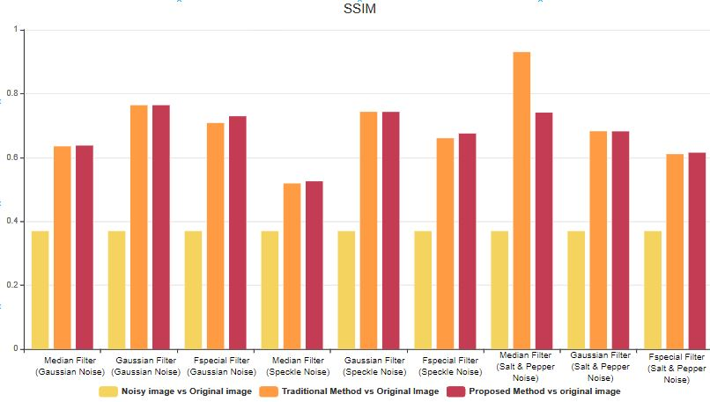

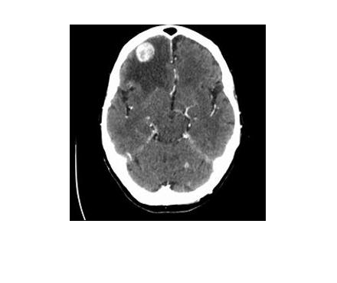 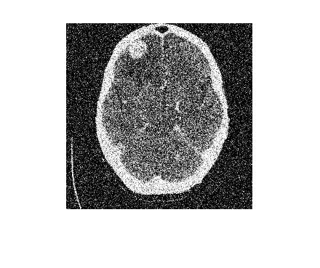 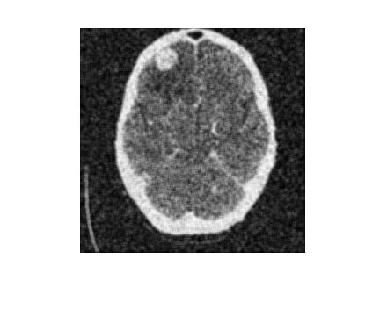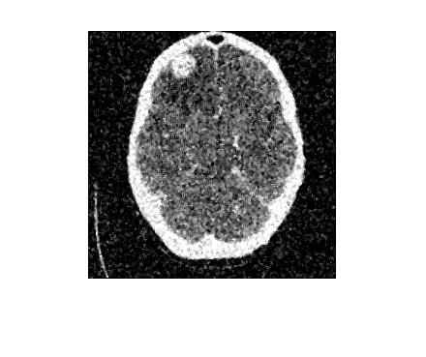

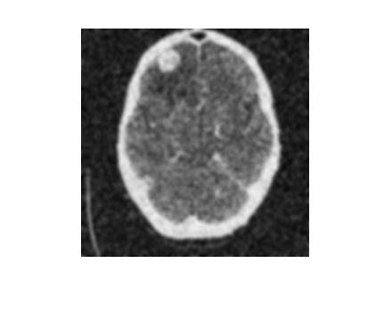 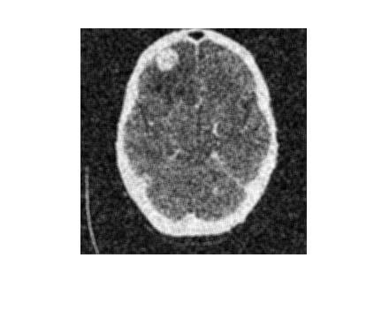

Performance of MRI brain images (a) Input image (b) Noisy image (Gaussian noise with variance 0.01) (c) applying median filter (d) Applying fspecial filter (e) Applying gaussian (f) Proposed method.

 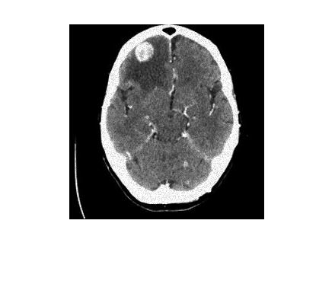

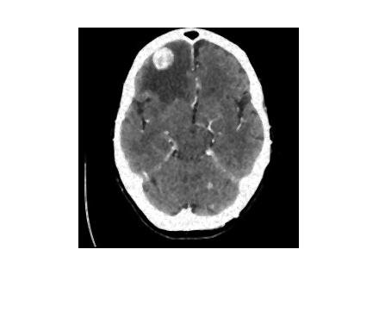 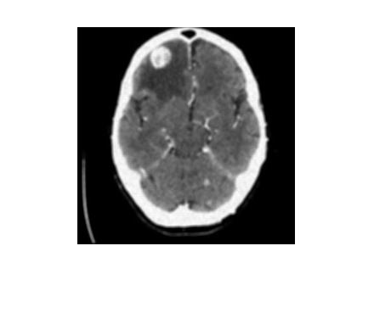

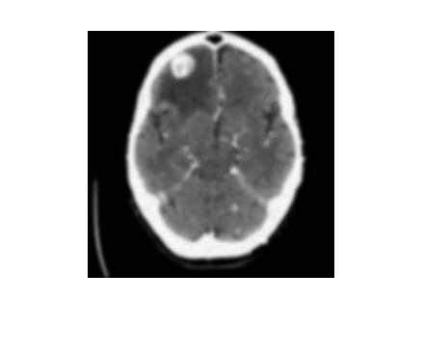 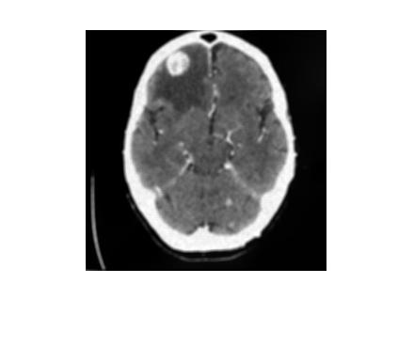

Performance of MRI brain images (a) Input image (b) Noisy image (Speckle noise with variance 0.01) (c) applying median filter (d) Applying fspecial filter (e) Applying gaussian (f) Proposed method.

 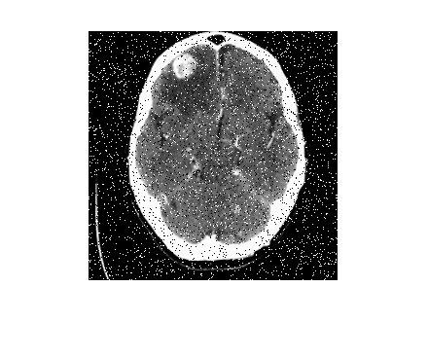

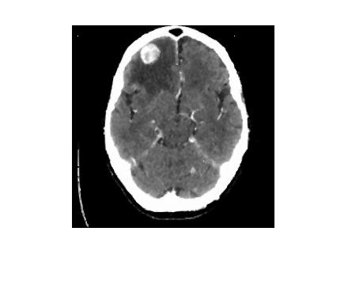 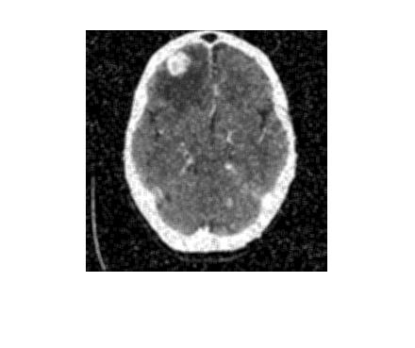

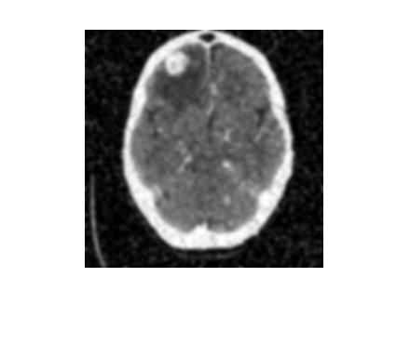 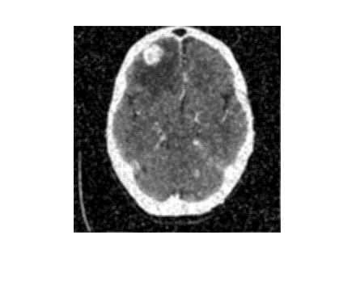

Performance of MRI brain images (a) Input image (b) Noisy image (Salt and pepper noise with variance 0.01) (c) applying median filter (d) Applying fspecial filter (e) Applying gaussian (f) Proposed method.

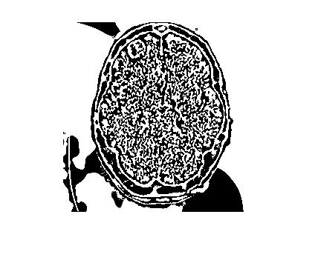 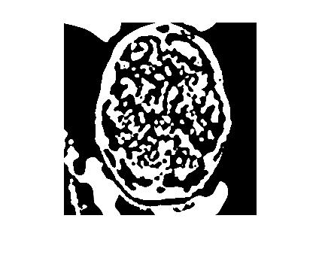

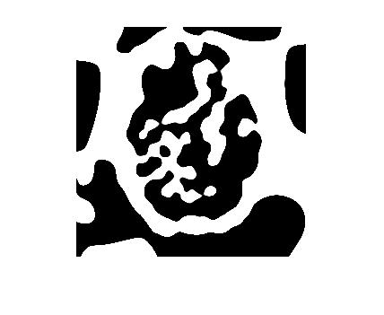 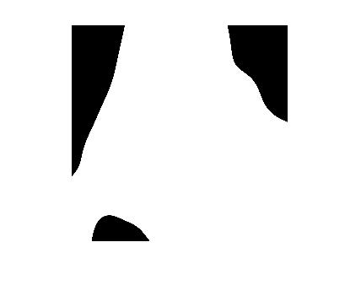

Performance of MRI brain images (a) IMF1 (b) IMF2 (c) IMF3 (d) Residue